**Getting Started:**

I used my time wisely in lessons and ensured that I could gain a basic understanding of HTML and CSS to help me progress throughout the process. I decided that I would look at other sites and get inspiration and ideas that I could potentially use in mine. So a combination of what we learnt in lessons and what I took away from research made it very quick and simple for me to get started and remain focused on the end goal of what I wanted to achieve from this assignment. The sites I got inspiration from are as followed:

* <https://joel.sh/>
* <https://www.ihm.co.uk/northamptonshire>
* <http://www.socialbrain.fr/>
* <http://thehideout.co.uk/>

**Designing Process:**

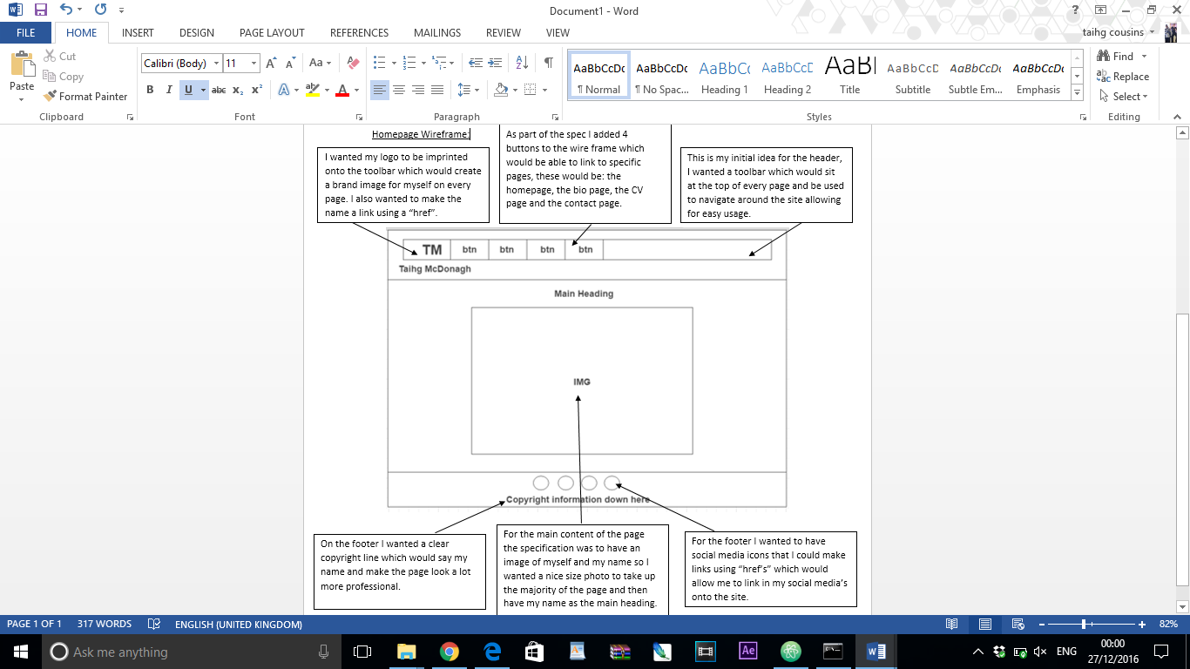For my homepage I wanted to create a simplistic but professional interface, I wanted a consistent sleek design for the toolbar which will be implemented onto every page. I wanted a prominent logo which would be embedding into the toolbar which give the website a branded image. For the footer I wanted to be able to link in my social Medias which would help with self-promotion. I went with a minimalist approach and kept everything basic but with the hint of quality and elegance.

For the CV page I wanted to have a clean and simple look for the page. I wanted the information to be the key element on the page. I wanted to be able to add in a main heading and an introduction to give people an understanding of what this page is all about.

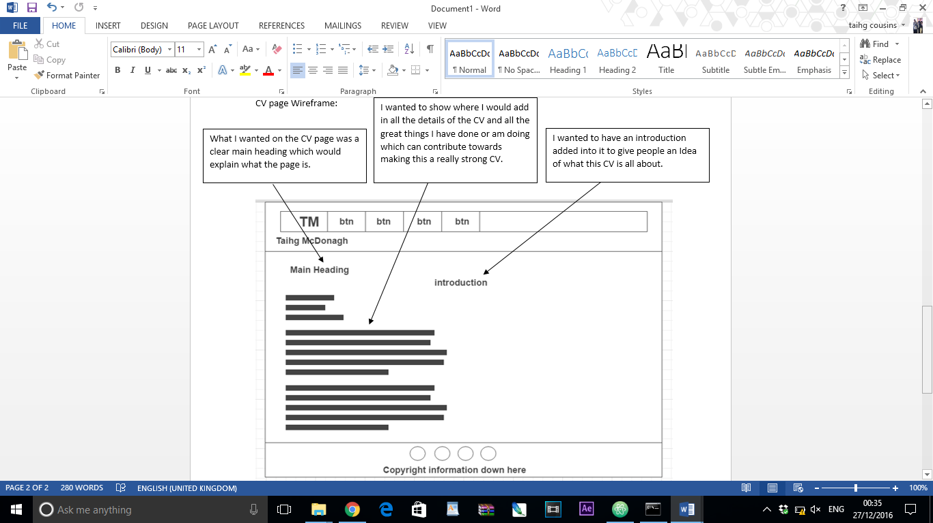

For the contact page I wanted to have a simple, easy to use form with easy to read descriptions and fitted to size boxes. This would make it very user friendly, and it was keep in fitting with the sleek professional design implemented throughout.

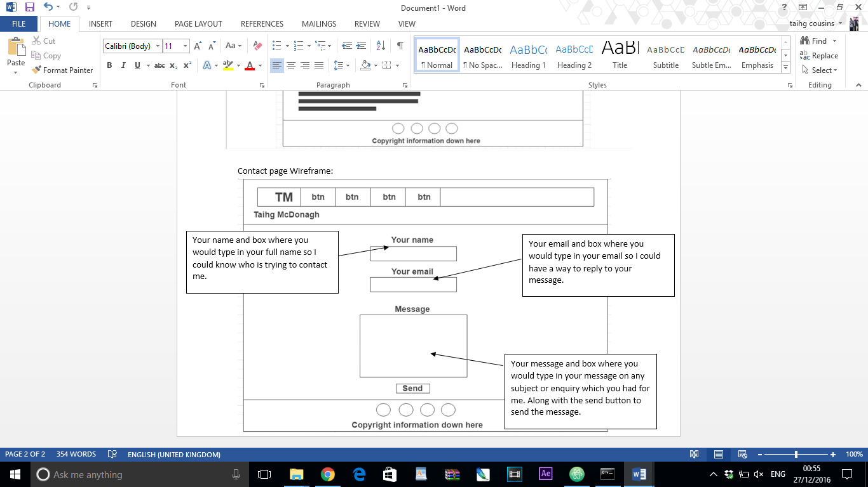

For the bio page, I wanted to be able to tell a story of my journey and I needed the write lay out for this, I wanted a clear heading to tell people what this page is about. I wanted to then have a small

For the bio page wireframe I wanted a main heading, a paragraph about my story and then I wanted to include pictures which would enhance the story I had planned.

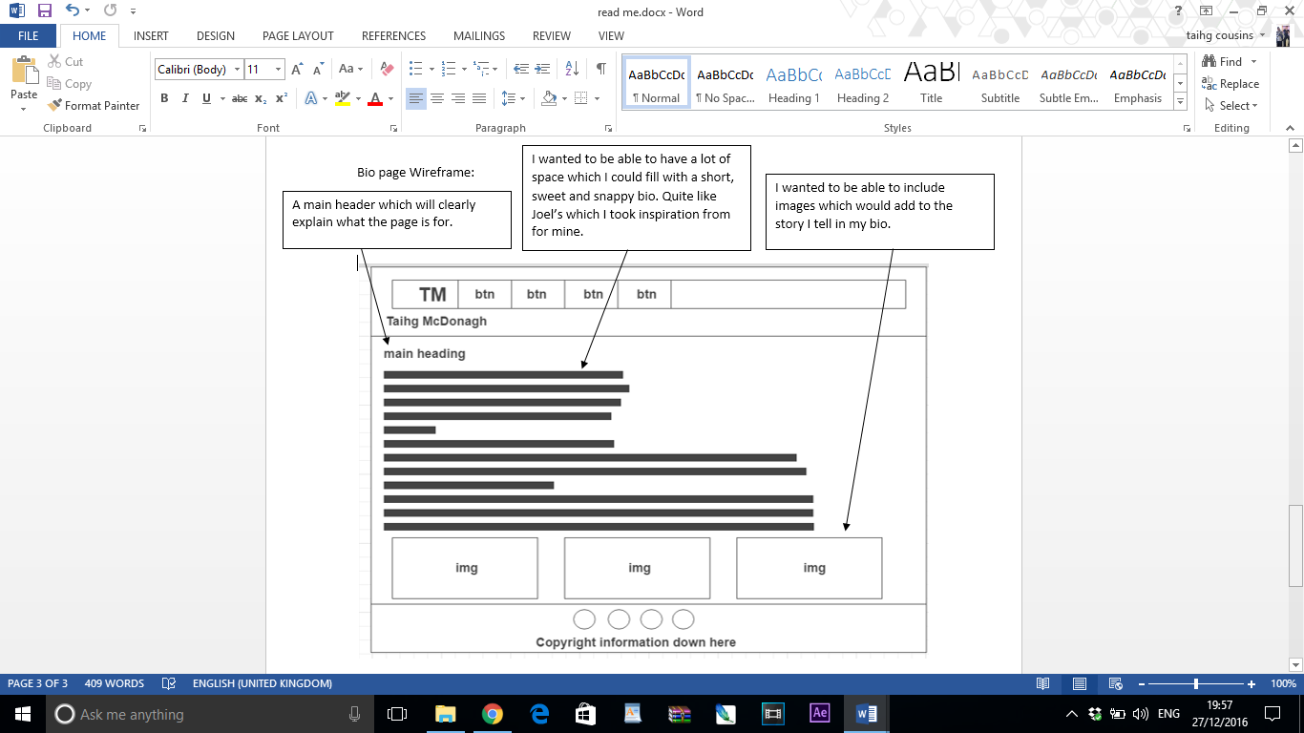

**Aspects of the work I correctly implemented:**

Keeping a consistent Design on all pages – I did this by making sure the banner and footer were the same on each page and the background of the main content remained the same also meaning the only thing that changed would be the content on each page. I researched and found a simplistic but professional looking design tutorial which worked with my website. I also used icons for my social Medias.

References:

<http://www.w3schools.com/css/css_navbar.asp>

<https://www.iconfinder.com/>

Using Animation – I used animation on the index page, with help from Tom in lesson and using part of his code from code pen, I was able to implement this correctly and have a good animation running on the main text of the home page.

References:

<http://codepen.io/UoN-ThomasRose/pen/rWYOve>

Having a favicon – I made my own favicon using Photoshop and researched how to get it into an icon format and reduce the size, I also researched how to implement this into my code.

References:

<http://realfavicongenerator.net>

<http://stackoverflow.com/questions/11893478/add-favicon-to-website>

having a logo – I created my own logo to sit in the top left corner of the screen, this was to give the website a more branded image, I also made it a link to my homepage like specified in the brief.

Optimization of images – I optimized all my images, reduced the file sizes and gave them all a unique twist by giving a border effect which looks like it is embedded into the background of the website.

Using a copyright tag – I used a copy right tag so that it would give the website a more official and professional feel.

Making images links – In several places I have implemented href’s to create links and enhance the user experience of the website. The first was the logo which was the part of the assignment brief to link back to home page, the second are the social media icons in the footer, they all link to my social medias, then on my CV page I added a few little mail icons next to the words “Further details are available upon request” and these little mail icons link to the contact page, also on the CV page I put my skills which are HTML and CSS and I added logos to represent this, then I made them logos links to take you to what these words mean, this is to make the site more user friendly to novice users. The last place I implemented this is on the bio page as to where I spoke about my time a Google HQ for the website myself and a team created, I attached a picture of the website which I made a link to the actual website.

Google API fonts – I used the google fonts in the correct way and implemented it into the code like requested on the brief, this gave the text on the website a nice fun character whilst keeping the professional quality you would expect of a formal CV.

Contact Form – I researched contact forms and used what I found out to create my own contact form which is clean and sleek and fits the websites feel.

References:

<http://www.w3schools.com/html/html_forms.asp>

Flex box – I used what we was taught in lesson to implement flex box into my design making the website more compatible.

**Aspects of the work I did not correctly implemented:**

Box model – given more time I would have liked to have implemented a side by side box style in the main content of the CV page and potentially the bio page.

**Whom I discussed the assignment with:**

Thasin Miah

Allie Cornelius

**Hours spent on the assignment:**

I did roughly 8hours on the assignment a week since my first commit to github on the 1st of November, this means that I approximately spent 88 hours in total working on the assignment.